SQL Processes Records

-- Data Exploration

~How many sales we have?

SELECT COUNT(*) as total_sale FROM retail_sales

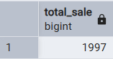

--How many uniuque customers we have ?

SELECT COUNT(DISTINCT customer_id) as total_sale FROM retail_sales

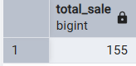

-- How many different category are there ?

SELECT DISTINCT category FROM retail_sales

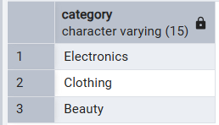

**Data Analysis & Business Key Problems & Answer**

-- Q.1 Write a SQL query to retrieve all columns for sales made on '2022-11-05

SELECT *

FROM retail_sales

WHERE sale_date = '2022-11-05';

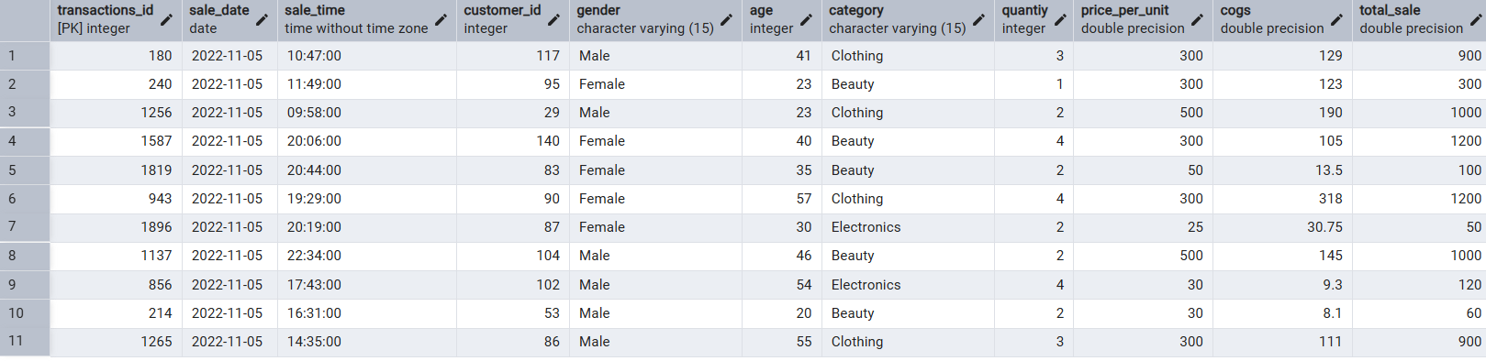

-- Q.2 Write a SQL query to retrieve all transactions where the category is 'Clothing' and the quantity sold is more than 4 in the month of Nov-2022

SELECT * FROM retail_sales

WHERE

category = 'Clothing'

AND

TO_CHAR(sale_date, 'YYYY-MM') = '2022-11'

AND

quantiy >= 4

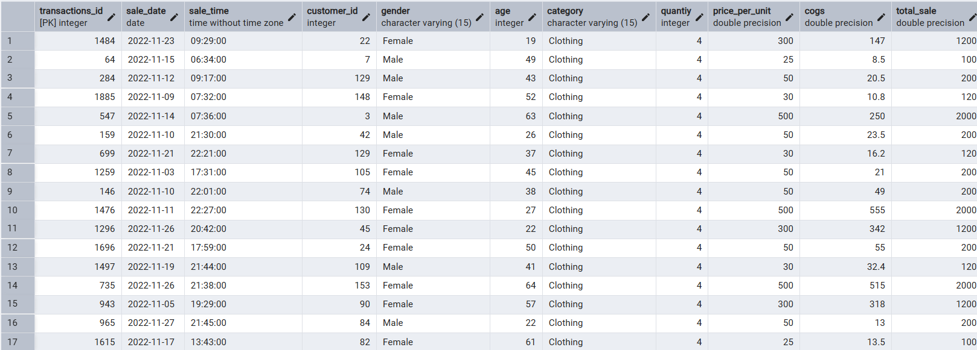

-- Q.3 Write a SQL query to calculate the total sales (total_sale) for each category.

SELECT

category,

SUM(total_sale) as net_sale,

COUNT(*) as total_orders

FROM retail_sales

GROUP BY 1

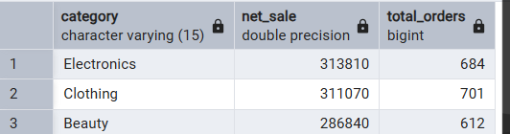

-- Q.4 Write a SQL query to find the average age of customers who purchased items from the 'Beauty' category.

SELECT

ROUND(AVG(age), 2) as avg_age

FROM retail_sales

WHERE category = 'Beauty'

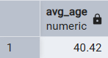

-- Q.5 Write a SQL query to find all transactions where the total_sale is greater than 1000.

SELECT * FROM retail_sales

WHERE total_sale > 1000

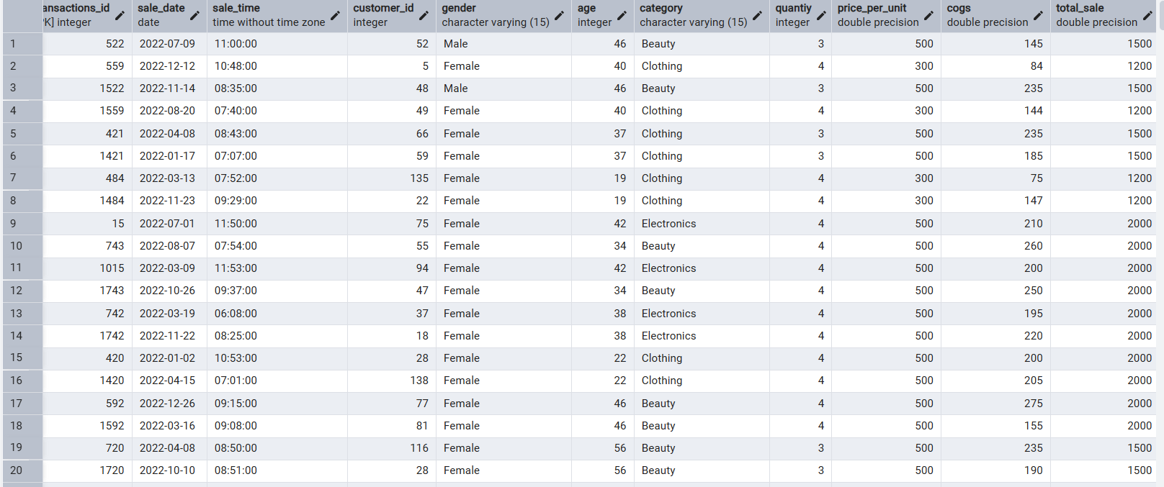

(around 306 value)

-- Q.6 Write a SQL query to find the total number of transactions (transaction_id) made by each gender in each category.

SELECT category, gender, COUNT(*) as total_trans FROM retail_sales

GROUP

BY

category,

gender

ORDER BY 1

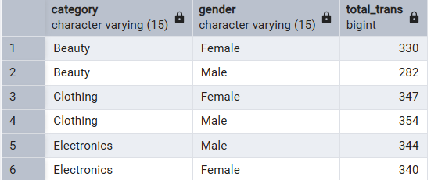

-- Q.7 Write a SQL query to calculate the average sale for each month. Find out best selling month in each year

SELECT

year,

month,

avg_sale

FROM

(

SELECT

EXTRACT(YEAR FROM sale_date) as year,

EXTRACT(MONTH FROM sale_date) as month,

AVG(total_sale) as avg_sale,

RANK() OVER(PARTITION BY EXTRACT(YEAR FROM sale_date) ORDER BY AVG(total_sale) DESC) as rank

FROM retail_sales

GROUP BY 1, 2

) as t1

WHERE rank = 1

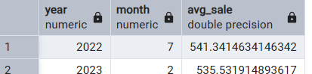

-- Q.8 Write a SQL query to find the top 5 customers based on the highest total sales

SELECT customer_id,

SUM(total_sale) as total_sales

FROM retail_sales

GROUP BY 1

ORDER BY 2 DESC

LIMIT 5

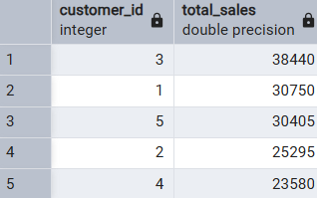

-- Q.9 Write a SQL query to find the number of unique customers who purchased items from each category.

SELECT

category,

COUNT(DISTINCT customer_id) as cnt_unique_cs

FROM retail_sales

GROUP BY category

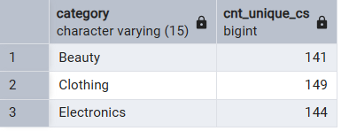

-- Q.10 Write a SQL query to create each shift and number of orders (Example Morning <12, Afternoon Between 12 & 17, Evening >17)

WITH hourly_sale

AS

(

SELECT *,

CASE

WHEN EXTRACT(HOUR FROM sale_time) < 12 THEN 'Morning'

WHEN EXTRACT(HOUR FROM sale_time) BETWEEN 12 AND 17 THEN 'Afternoon'

ELSE 'Evening'

END as shift

FROM retail_sales

)

SELECT

shift,

COUNT(*) as total_orders

FROM hourly_sale

GROUP BY shift

